
MGT1031
International Business
Impact of Exchange Rate Volatility on Export Performance
Report

Mohamed Riyaz S
21MIA1138

TABLE OF CONTENTS:
Abstract…………………………………………………………………………………………….………4
1. Introduction………………………………………………………………………………….……….4
1.1 Background of the Study…………………………………………………………….…………4
1.2 Importance of Exchange Rates in International Trade…………………….……..5
1.3 Role of Exchange Rate Volatility in Export Uncertainty……………….………...5
1.4 Relevance to Emerging Economies (India)……………………………………..………5
2. Problem Statement………………………………………………………………………..………6
2.1 The Exporter’s Dilemma: Risk and Reality……………………………………..…..….6
2.2 The Policy Tightrope………………………………………………………………………………6
2.3 Why This Research Matters……………………………………………………………………7
3. Objectives of the Study………………………………………………………………………….7
4. Scope of the Study……………………………………………………………………….………..7
5. Literature Review………………………………………………………………………………..…9
6. Data & Methodology………………………………………………………………….……….…12
6.1 Dataset Description………………………………………………………………………………12
6.2 Variables in the Dataset…………………………………………………………………..……12
6.3 Nature of the Dataset………………………………………………………………….…….…13
7. Research Design…………………………………………………………………………..……....13
7.1 Quantitative and Econometric Approach………………………………………………13
7.2 Time-Series Analysis Framework…………………………………………………..………13
8. Methodological Framework………………………………………………………………….14
8.1 Descriptive Statistics……………………………………………………………………….……14
8.2 Trend Analysis………………………………………………………………………….………….15
8.3 Stationarity Test (ADF) …………………………………………………………………….….15
8.4 Correlation Analysis…………………………………………………………………………….16
8.5 ARCH Effect Test…………………………………………………………………………….…….17
8.6 GARCH (1,1) Volatility Modeling……………………………………………..……………17
8.7 Regression Analysis…………………………………………………………………..…………18
8.8 Granger Causality Test…………………………………………………………………………18
9. Results & Analysis………………………………………………………………………….19
9.1 Descriptive Statistics Results…………………………………………………………19
9.2 Trend Analysis Results………………………………………………………….……….21
9.3 Stationarity Results……………………………………………………………….……..24
9.4 Correlation Results………………………………………………………………..……..25
9.5 ARCH & GARCH Results…………………………………………………………..……27
9.6 Regression Results…………………………………………………………………..…..28
9.7 Granger Causality Results……………………………………………………….……29
10. Discussion of Findings………………………………………………………….……..30
11. Conclusion…………………………………………………………………………….……30
11.1 Summary of Key Findings……………………………………………………………30
11.2 Policy Implications…………………………………………………………………..…31
11.3 Limitations of the Study…………………………………………………………..…32
11.4 Future Scope……………………………………………………………………..………32
12. References…………………………………………………………………….…………..33

Abstract:
Exchange rate volatility has emerged as a critical factor influencing international trade, particularly for export-oriented economies operating in increasingly integrated and uncertain global markets. This study examines the impact of exchange rate volatility on export performance using a time-series econometric framework. Focusing on macroeconomic data over the period 2000–2023, the analysis incorporates key variables such as exchange rates, export values, exchange rate volatility, GDP growth, inflation, and interest rates to capture both trade dynamics and broader economic conditions.
Exchange rate volatility is modeled using a GARCH (1,1) approach to account for time-varying and clustered volatility commonly observed in financial data. Prior to estimation, the stationarity properties of the variables are tested using the Augmented Dickey–Fuller (ADF) test to ensure robust econometric inference. The empirical analysis employs descriptive statistics, trend analysis, correlation analysis, regression modeling, and Granger causality tests to explore both the magnitude and direction of the relationship between exchange rate volatility and export performance.
The results indicate the presence of significant volatility clustering in exchange rate movements, confirming the suitability of GARCH-based modeling. Regression findings reveal that exchange rate volatility exerts a statistically significant influence on export performance, highlighting the sensitivity of exports to currency uncertainty. Granger causality results further demonstrate a unidirectional causal relationship running from exchange rate volatility to exports, particularly in the short run. These findings suggest that increased exchange rate uncertainty affects exporters’ pricing, revenue expectations, and trade decisions.
Overall, the study underscores the importance of maintaining exchange rate stability to support export growth. The findings carry important implications for policymakers in designing exchange rate and monetary policies, as well as for exporters in adopting effective currency risk management strategies to mitigate the adverse effects of exchange rate volatility on international trade.
Keywords: Exchange Rate Volatility, Export Performance, International Trade, GARCH Model, Time-Series Analysis, Emerging Economies

1. Introduction:
1.1 Background of the Study:
International trade is an integral aspect of the economic development and expansion of countries as it helps countries focus on their area of specialization based on their comparative advantage. An important element that influences and shapes international trade is the exchange rate, which is referred to as the value of a country’s currency when it is measured against another currency. Exchange rates directly impact export and import prices, foreign investments, and international trade. With an increased focus on international trading and the linkage of financial markets with increasing globalization, exchange rates have become increasingly dynamic, and such dynamics form an important area of focus when studying international business and finance.
1.2 Importance of Exchange Rates in International Trade:
The exchange rates can greatly impact a country’s exports because they determine the prices of a country’s goods internationally. When a country’s currency devaluates, it will mean that its exports will be priced lower, which will help boost exports, but when a country’s currency appreciates, it will lead to increased prices of exports, thereby lowering exports.
Apart from the impact on prices, exchange rates can affect firms in other ways related to revenue and profitability. Some firms that deal in exports are involved in contracts agreed upon in foreign currencies and through such contracts become sensitive to exchange rate fluctuations. A slight variation in exchange rates can create problems for firms in terms of profitability and investment. Exchange rate stability can be desirable for the growth of trade, whereas unpredictability can create problems in trade.
1.3 Role of Exchange Rate Volatility in Export Uncertainty:
Although the extent of the exchange rate is a concern, volatility of the exchange rate is even more of a problem to an exporter. Volatility creates uncertainty in future income and expenses, particularly when income is realized in payments made at a later date. Such uncertainty will act to discourage businesses from engaging in global markets or from expanding their business of exporting their products.
Volatility in exchange rates amplifies the risk associated with trade, because in these cases, exporter firms might experience losses when a contract is signed. This might happen when exchange rates do not favor them when it is time to pay. It means that some firms, preferring to avoid risk, might cut back on their exports, shorten the time of contracts, or concentrate on local trade. It should be noted that while some financial tools, such as forward contracts, act as risk management systems, such tools might not be readily available or affordable by small-to-medium enterprises.
1.4 Relevance to Emerging Economies (like India)
The impact of exchange rate volatility is especially pronounced in emerging economies, which often experience greater currency fluctuations due to factors such as capital flow volatility, external debt exposure, inflation differentials, and sensitivity to global economic shocks. In such economies, exports are a crucial engine of growth, employment generation, and foreign exchange earnings.
For countries like India, exports contribute significantly to GDP growth and help finance imports of essential goods such as crude oil, technology, and capital equipment. However, the Indian economy has historically faced periods of exchange rate instability due to global financial crises, changes in monetary policy in advanced economies, and fluctuations in foreign capital inflows. These movements can create uncertainty for Indian exporters across sectors such as textiles, pharmaceuticals, information technology services, and manufacturing.
Studying the impact of exchange rate volatility on export performance in emerging economies is therefore of high policy relevance. It helps policymakers design appropriate exchange rate regimes, monetary policies, and trade-support measures to reduce uncertainty and enhance export competitiveness. Additionally, such analysis provides valuable insights for businesses and investors in formulating effective risk-management and internationalization strategies.
In summary, understanding the relationship between exchange rate volatility and export performance is essential for explaining trade dynamics in an increasingly globalized world. This study is particularly relevant for emerging economies, where managing exchange rate risk is critical for sustaining export-led growth and achieving long-term economic stability.

2. Problem Statement
2.1 The Exporter’s Dilemma: Risk and Reality
For someone selling goods abroad, a volatile currency feels like trying to hit a moving target.
- The Payment Gap: Between the day a contract is signed and the day the check clears, the exchange rate might shift. A profitable deal can turn into a loss overnight simply because of currency fluctuations.
- The Ripple Effect: This uncertainty forces business owners to be defensive. They might hike prices to cover potential losses, put off hiring new staff, or cancel plans to expand into new countries.
- The Vulnerability of Small Businesses: While giant corporations have "hedging" tools (essentially insurance against currency drops), smaller businesses often don't. They are the first to retreat to the safety of the domestic market when things get bumpy.
2.2 The Policy Tightrope
For policymakers and central banks, exchange rate volatility is a constant headache that complicates every decision they make.

Challenge | Impact on Policy
Inflation Control | A sudden drop in the local currency makes imports (like oil or food) more expensive, driving up the cost of living.
Competitiveness | If the currency is too strong, exports become too expensive for foreign buyers; if it’s too volatile, trade partners lose trust.
Investor Confidence | Global investors dislike unpredictability. If a currency is swinging wildly, they are likely to pull their money out, leading to further instability.

2.3 Why This Research Matters
Understanding the "why" and "how" behind these fluctuations isn't just an academic exercise—it’s a blueprint for stability. By studying these patterns, governments can:
- Design Safety Nets: Create credit facilities or insurance programs that help small businesses survive currency shocks.
- Coordinate Strategy: Ensure that the Central Bank (trying to stop inflation) and the Trade Ministry (trying to boost exports) aren't accidentally working against each other.
- Targeted Intervention: Decide exactly when the government should step into the market to stabilize the currency versus when they should let it find its own level.

The Bottom Line

Ultimately, a stable exchange rate acts as the "infrastructure" of international trade. When the policy environment is predictable, businesses feel confident enough to innovate and compete globally, which leads to long-term economic health for everyone.

3. Objectives of the Study

The primary objective of this study is to gain a comprehensive understanding of how exchange rate movements and volatility influence export performance over time. To achieve this, the study focuses on the following specific objectives:
- To examine the historical behavior and underlying trends in exchange rates and export performance, thereby identifying patterns and long-term movements that characterize their relationship.
- To test the time-series properties of the variables used in the analysis by examining their stationarity, ensuring the reliability and validity of subsequent econometric modeling.
- To estimate and quantify exchange rate volatility using GARCH-based models, which are well suited to capture time-varying volatility commonly observed in financial and macroeconomic data.
- To evaluate the effect of exchange rate volatility on export performance, with the aim of understanding whether increased uncertainty in exchange rates enhances or constrains export growth.
- To investigate the presence and direction of causal linkages between exchange rate volatility and exports using Granger causality analysis, thereby determining whether exchange rate movements influence export performance, or vice versa.
These objectives collectively help in building an empirical framework that explains the dynamic relationship between exchange rate volatility and export performance, offering insights relevant to both policymakers and export-oriented firms.
4. Scope of the Study
This study is confined to a time-series–based macroeconomic analysis, focusing on the behavior of exchange rates and export performance over a specified period. By using historical data observed across time, the analysis captures both short-term fluctuations and long-term movements in the variables under consideration.
The scope is primarily centered on examining the relationship between exchange rate dynamics and export performance. Rather than covering multiple macroeconomic factors, the study deliberately narrows its focus to understand how changes and volatility in exchange rates influence export outcomes. This focused approach allows for a clearer interpretation of the exchange rate–export linkage and its economic implications.
To achieve reliable and objective results, the study employs well-established econometric and statistical techniques. These methods are used to analyze trends, test time-series properties, model exchange rate volatility, and evaluate causal relationships. The use of quantitative tools ensures that the findings are data-driven and empirically grounded, making them relevant for academic analysis as well as for policy and business decision-making.

5. Literature Review:
S. No. | Author(s), Year | Method / Approach | Key contribution | Gap identified:
1. | Bahmani-Oskooee & Saha, 2021 | Quarterly bilateral trade analysis (nonlinear/ARDL-type methods), tests for asymmetric effects. | Shows short-run and long-run asymmetric effects of exchange-rate volatility on India’s trade with key partners — volatility increases affect partners differently. | Limited to India’s 14 partners — generalizability to other emerging economies or sectoral breakdowns is limited.
2. | Tarakçı, Ölmez & Durusu-Çiftci, 2022 | Monthly data, GARCH volatility measurement + nonlinear estimation (partial-sum) across commodity types and trading partners. | Finds asymmetric and commodity-specific effects of exchange-rate volatility on Turkey’s exports; volatility impact varies by commodity type. | Focused on Turkey — cross-country or firm-level heterogeneity not addressed.
3. | Balomenou & GPT (journal), 2022 | Panel/quarterly econometrics using volatility proxies and trade regressions. | Documents a positive long-run relationship between volatility and exports for select country pairs, highlighting time-varying significance. | Results vary by time horizon — limited explanation of mechanisms (hedging, contract structures).
4. | Lal, 2023 | Literature mapping & empirical synthesis across studies; meta-analysis elements. | Synthesizes recent findings and identifies major themes: asymmetric effects, heterogeneous country responses, and the role of policy/hedging. | More primary empirical work needed to reconcile conflicting findings across regions.
5. | Handoyo et al., 2023 | ARCH/GARCH for volatility estimation + (nonlinear) ARDL for ASEAN-5 manufacturing commodity exports. | Finds both symmetric and asymmetric influences — exchange-rate volatility significantly influences manufacturing exports across ASEAN countries. | Sectoral disaggregation is limited to manufacturing; services exports not covered.
6. | Andersson, 2024 | Country case study (Sweden, Finland), GARCH volatility measure + ARDL + Granger causality. | Evidence that volatility sometimes increases trade in certain advanced-economy contexts (positive long-run relationship found for Sweden). | Mechanisms for positive relationship (pricing to market, trade invoicing currency) need deeper micro-level evidence.
7. | Audi, 2024 | Panel/time-series ARDL and cointegration across China, Pakistan, India. | Finds generally negative and significant impacts of exchange-rate volatility on exports for several developing countries. | Mixed country results suggest the role of country-specific institutions and hedging markets needs exploration.
8. | Rojid, 2024 | ARDL bounds testing + ECM for small economies; GARCH for volatility series. | Finds positive and significant effects of volatility on exports in the short and long run for certain small economies (context-dependent). | Heterogeneity across small economies not deeply unpacked — policy and market structure influences unclear.
9. | Cherkaoui, 2023 | Disaggregated panel for Moroccan exports using GARCH(1,1) to measure volatility + random effects model. | Sectoral elasticities estimated — some export categories are more sensitive to volatility than others. | • Annual data limits short-run dynamics and higher-frequency effects.  •
10. | Shongwe, 2023 | Vector models + Granger-type causality tests; assesses causality between exports and exchange-rate uncertainty. | Finds uni- or bi-directional causality in different settings — in some cases exports Granger-cause exchange-rate uncertainty. | Causality tests are sensitive to lag selection and frequency; micro-foundations remain unexplored.
11. | Bosupeng, 2024 | Cross-country panel; explores volatility’s interaction with devaluation shocks (short/long run). | Shows that volatility modifies the effectiveness of devaluations on trade balances — effects differ between developed & developing countries. | The role of hedging markets and contract currency is not explicitly modeled.
12. | Ene, 2023 | GARCH + Granger causality + OLS on agricultural export commodities (Nigeria). | Demonstrates high exchange-rate volatility for the period and negative short-run effects on selected commodity exports. | Focus on agricultural crops — manufacturing and services omitted.
13. | Ouattara et al., 2022/2023 | Panel-ARDL and cointegration tests for Sub-Saharan countries; volatility proxies via GARCH. | Finds negative impact of exchange-rate volatility on exports in SSA, both short and long run. | Heterogeneity within SSA countries and the role of external shocks require further study.
14. | Peştere-akçay, (2022/2023) | ARDL with CPI and other controls; country case evidence. | Suggests volatility can, in some settings, boost trade more than other macro factors — results are nuanced. | Contrasting results across studies highlight need for standardized volatility measurement.
15. | Jyoti, 2024 | Time-series GARCH + ARDL for manufacturing export subsectors. | Mixed effects observed: volatility has differential impacts across manufacturing sectors (some hurt, some benefit). | Micro-level firm responses (pricing strategies, hedging adoption) not analyzed.
6. Data & Methodology
6.1 Dataset Description
The dataset used in this study is a secondary, time-series macroeconomic dataset designed to analyze the relationship between exchange rate volatility and export performance. The data consists of periodic observations (monthly/quarterly/annual) collected over multiple years, allowing for trend, volatility, and causal analysis.
The dataset integrates key international trade and macroeconomic indicators commonly used in international business and financial analytics research.
6.2 Variables in the Dataset
- Date / Year - Time period of observation
- Exchange Rate - Nominal exchange rate of domestic currency against a major foreign currency (e.g., INR/USD)
- Exchange Rate Volatility - Volatility measure computed using rolling standard deviation or ARCH/GARCH models
- Exports Value - Total export value (in USD or local currency)
- Export Growth Rate - Percentage change in export values
- GDP - Gross Domestic Product (control variable)
- Inflation Rate - Consumer Price Index (CPI) based inflation
- Interest Rate - Policy or lending interest rate
- Trade Openness- Ratio of total trade (Exports + Imports) to GDP

6.3 Nature of the Dataset
- Type: Quantitative
- Structure: Time-series
- Frequency: Monthly / Quarterly / Annual
- Source: International financial databases (World Bank, IMF, OECD, RBI)
- Scope: Macro-level analysis of international trade dynamics
- Purpose of the Dataset

This dataset is structured to:
- Measure exchange rate volatility patterns
- Assess export sensitivity to currency fluctuations
- Identify short-run and long-run impacts of exchange rate movements
- Support econometric and statistical modeling

7. Research Design

7.1 Quantitative and Econometric Approach

This study adopts a quantitative and econometric approach to empirically examine the impact of exchange rate volatility on export performance. Quantitative methods are particularly suitable for this research as they enable objective measurement of relationships between macroeconomic variables using numerical data. By relying on observed historical data, the study ensures that conclusions are grounded in empirical evidence rather than subjective interpretation.

Econometric techniques are employed to model the complex and dynamic relationship between exchange rates and exports. Exchange rate volatility, which cannot be directly observed, is quantified using appropriate volatility models that capture time-varying fluctuations. Regression-based frameworks are then used to evaluate how changes in exchange rate volatility influence export performance while controlling for other relevant macroeconomic factors. This approach allows the study to estimate both the magnitude and statistical significance of the impact, providing clear insights into whether exchange rate uncertainty acts as a constraint or a stimulus to export growth.

The use of advanced econometric tools also helps address common issues in macroeconomic data, such as autocorrelation, heteroskedasticity, and endogeneity. By applying diagnostic and robustness checks, the study enhances the reliability of its findings and ensures that the estimated relationships reflect true economic behavior rather than statistical artifacts.

7.2 Time-Series Analysis Framework

The research is structured within a time-series analysis framework, which is well suited for examining macroeconomic variables that evolve over time. Time-series analysis allows the study to capture both short-term fluctuations and long-term trends in exchange rates and export performance. This framework is particularly important for understanding how temporary shocks and persistent volatility in exchange rates affect exports across different time horizons.

As a first step, the time-series properties of the variables are examined to determine their stationarity. Testing for stationarity is essential to avoid spurious regression results and to ensure that valid inferences can be drawn from the data. Depending on the results, appropriate transformations or differencing techniques are applied to stabilize the series.

The framework further incorporates models that account for dynamic interactions between variables, allowing past values of exchange rates and volatility to influence current export performance. Long-run relationships and short-run adjustments are analyzed to understand how exports respond over time to exchange rate uncertainty. Additionally, causality tests are used to identify the direction of influence between exchange rate volatility and export performance, providing insights into whether exchange rate movements drive exports or whether export dynamics themselves influence exchange rate behavior.

Overall, the time-series analysis framework provides a comprehensive structure for analyzing the dynamic and evolving relationship between exchange rate volatility and export performance. It enables the study to capture the temporal nature of economic interactions and offers valuable implications for policymakers and exporters concerned with managing exchange rate risk.

8. Methodological Framework

8.1 Descriptive Statistics

Descriptive statistics provide a preliminary understanding of the underlying characteristics of the data used in the study. Measures such as the mean, median, and standard deviation are employed to summarize the central tendency and dispersion of key variables related to exchange rates, exchange rate volatility, and export performance. The mean represents the average value over the study period, while the median indicates the central value, reducing the influence of extreme observations. The standard deviation reflects the extent of variability in the data, highlighting how widely the observations deviate from their average values. Together, these measures offer an initial overview of the stability or variability present in the macroeconomic variables.

In addition to these measures, skewness and kurtosis are used to examine the shape of the data distribution. Skewness indicates the degree of asymmetry in the distribution. A skewness value close to zero suggests that the data are approximately symmetrically distributed around the mean. Positive skewness implies a right-skewed distribution, where higher values occur less frequently but have a longer tail. In the context of exchange rate volatility and exports, right-skewness may indicate that periods of high volatility or unusually large export changes occur infrequently but have a significant impact when they do, pointing toward potential asymmetric effects.

Kurtosis measures the thickness of the tails of the distribution and the concentration of observations around the mean. Higher kurtosis values indicate the presence of extreme observations or sharp fluctuations, which are particularly relevant in exchange rate studies where financial variables often experience sudden shocks. Such extreme movements can increase uncertainty and risk for exporters and policymakers. Analyzing kurtosis therefore helps in understanding the likelihood of extreme exchange rate movements and their potential influence on export performance.

Overall, descriptive statistics serve as an essential diagnostic step in time-series analysis. They help assess distributional properties, identify volatility patterns, and provide insights into data behavior before applying advanced econometric models. This preliminary analysis ensures that subsequent modeling is based on a clear understanding of the variability and distributional characteristics of the data.

8.2 Trend Analysis

A time-series–based trend analysis was undertaken to study the historical movement of the exchange rate, exchange rate volatility, and export performance throughout the study period. The time dimension of the dataset was clearly identified and used to preserve the correct chronological order of observations, allowing the analysis to accurately capture changes over time. Key numerical macroeconomic variables were selected to ensure a targeted and effective quantitative assessment. Trend patterns were examined through line plots, which helped illustrate both short-term fluctuations and long-term directional movements. Additionally, moving average methods were employed to reduce short-term noise in the data and emphasize underlying long-run trends. This exploratory analysis offered preliminary evidence on the relationship between exchange rate dynamics, volatility, and export performance, providing a solid basis for further econometric investigation.

The trend analysis provides a clear understanding of the long-term behavior of key macroeconomic variables by tracing their movement over time. By examining these trends, it becomes possible to identify persistent patterns, gradual shifts, and phases of stability or instability in exchange rates and export performance. The use of moving average techniques plays a crucial role in minimizing short-term volatility and irregular fluctuations that may arise due to temporary shocks or cyclical factors. This smoothing process helps reveal the underlying direction of change, making long-run trends more visible and easier to interpret.

Through this approach, the analysis enables a clearer comparison between periods of rising or falling exchange rates and corresponding movements in export performance. It also assists in detecting structural changes or turning points that may coincide with policy shifts, global economic events, or market adjustments. Overall, trend analysis combined with moving averages supports a more meaningful economic interpretation by distinguishing long-term tendencies from short-term noise, thereby offering valuable preliminary insights into how exchange rate dynamics may influence export behavior over time.

8.3 Stationarity Test (ADF)

The Augmented Dickey–Fuller (ADF) test was applied to assess the stationarity characteristics of the time-series variables used in the study. Stationarity is a critical assumption in time-series econometric analysis, as non-stationary data can lead to misleading or spurious regression results. The null hypothesis (H₀) of the ADF test states that the time series contains a unit root and is therefore non-stationary, while the alternative hypothesis (H₁) suggests that the series is stationary.

The decision rule is based on the probability (p-value) associated with the test statistic. If the p-value is less than or equal to the chosen significance level (0.05), the null hypothesis is rejected, indicating that the series is stationary and suitable for direct econometric modeling. Conversely, if the p-value exceeds 0.05, the null hypothesis cannot be rejected, implying that the series is non-stationary and exhibits time-dependent statistical properties such as changing mean or variance.

The results of the ADF test reveal that variables with p-values greater than 0.05 are non-stationary in their levels. This indicates the presence of a unit root and suggests that shocks to these variables may have persistent effects over time. To address this issue, differencing of the non-stationary series is required to transform them into stationary form. Differencing helps remove trends and stabilize the mean of the series, making the data suitable for further econometric procedures such as regression analysis, cointegration testing, volatility modeling, and causality analysis.

Overall, the application of the ADF test ensures the robustness and validity of subsequent analyses by confirming that the time-series properties of the variables are appropriately handled. Establishing stationarity prior to model estimation strengthens the reliability of the results and supports meaningful economic interpretation of the relationship between exchange rate volatility and export performance.

8.4 Correlation Analysis

Correlation analysis is used as an initial diagnostic tool to examine the degree and direction of association between exchange rate, exchange rate volatility, export performance, and other selected macroeconomic variables. In this study, the Pearson correlation coefficient is employed, as it measures the strength of linear relationships between continuous variables. The resulting correlation matrix provides a concise numerical summary of how variables move in relation to one another.

To enhance interpretability, the correlation matrix is visualized using a heatmap, where color intensity represents the magnitude and direction of correlations. This graphical representation allows for quick identification of strong positive, strong negative, or weak relationships among variables. Heatmaps are particularly useful in multivariate datasets, as they help detect patterns, clusters, and potential interdependencies that may not be immediately evident from numerical values alone.

Correlation values range between −1 and +1. A value close to +1 indicates a strong positive linear relationship, meaning that the variables tend to move in the same direction. A value close to −1 reflects a strong negative linear relationship, where an increase in one variable is associated with a decrease in another. A correlation value near 0 suggests the absence of a linear relationship, indicating that movements in one variable do not systematically correspond to changes in the other.

The correlation analysis serves as a preliminary assessment of relationships prior to applying advanced econometric models. While correlation does not imply causation, it provides useful initial insights into the potential links between exchange rate volatility and export performance. These insights help guide model selection, identify variables that may be strongly associated, and highlight the need for further investigation through regression analysis, volatility modeling, and causality testing.

8.5 ARCH Effect Test

The ARCH Effect Test is conducted to examine whether the variance of the exchange rate series remains constant over time or exhibits time-varying behavior. In financial and macroeconomic time-series data, volatility often appears in clusters, where periods of high variability are followed by similar periods, and low-volatility phases tend to persist as well. Detecting such patterns is essential before modeling volatility, as traditional econometric models assume constant variance and may produce unreliable results when this assumption is violated.

In this study, the ARCH–LM (Lagrange Multiplier) test is applied to identify the presence of conditional heteroskedasticity in the exchange rate series. The null hypothesis (H₀) states that no ARCH effect exists, implying that the variance is constant over time. The alternative hypothesis (H₁) suggests the presence of an ARCH effect, indicating that volatility is time-dependent and clustered.

The decision rule is based on the p-value of the test statistic. If the p-value is less than or equal to 0.05, the null hypothesis is rejected, providing evidence of time-varying volatility in the series. If the p-value exceeds 0.05, the null hypothesis cannot be rejected, implying that the variance is stable and does not exhibit ARCH behavior.

The test results reveal statistically significant evidence of conditional heteroskedasticity in the exchange rate series, confirming the existence of volatility clustering. This finding is particularly relevant in exchange rate studies, as currency markets are prone to sudden shocks and persistent volatility. The presence of ARCH effects justifies the use of ARCH and GARCH family models, which are specifically designed to capture and model changing volatility over time. Consequently, applying GARCH-type models enables a more accurate estimation of exchange rate volatility and strengthens the empirical analysis of its impact on export performance.

8.6 GARCH (1,1) Volatility Modeling

The GARCH (1,1) model is employed to estimate and analyze time-varying volatility in the exchange rate series. Unlike conventional models that assume constant variance, the GARCH framework allows volatility to change over time, making it particularly suitable for financial and macroeconomic data where periods of high and low volatility tend to cluster. By capturing this dynamic behavior, the model provides a realistic representation of exchange rate uncertainty.

The primary purpose of applying the GARCH (1,1) model in this study is to quantify exchange rate volatility and examine its persistence over time. The model incorporates both the impact of recent shocks and past volatility, enabling a comprehensive understanding of how unexpected movements in exchange rates influence current and future volatility levels. This is essential for assessing how sustained volatility may affect export performance and decision-making by exporters.

Within the GARCH (1,1) framework, key parameters offer important economic interpretations. The constant term represents the long-run average level of volatility. The ARCH parameter reflects the immediate impact of new shocks on volatility, indicating how sensitive the exchange rate is to sudden changes. The GARCH parameter measures volatility persistence, showing the extent to which past volatility continues to influence current volatility.

The estimated results indicate pronounced volatility clustering in the exchange rate series, as evidenced by statistically significant persistence parameters. This suggests that shocks to exchange rate volatility do not dissipate quickly but instead have lasting effects over time. Such persistence highlights the relevance of exchange rate uncertainty for exporters, as prolonged periods of volatility can influence pricing, contract decisions, and risk exposure. Overall, the findings confirm the appropriateness of the GARCH (1,1) model for analyzing exchange rate volatility and its implications for export performance.

8.7 Regression Analysis

Regression analysis is employed to empirically evaluate the relationship between exchange rate volatility and export performance. In this study, an Ordinary Least Squares (OLS) regression framework is used, where exchange rate volatility is specified as the independent variable and exports are treated as the dependent variable. This approach allows for a direct and measurable assessment of how changes in currency uncertainty influence export outcomes.

The main objective of the regression analysis is to quantify the effect of exchange rate volatility on exports and to determine whether this effect is statistically significant. By estimating the regression coefficients, the model provides insights into the direction and magnitude of the relationship, indicating whether increased volatility acts as a constraint or stimulus to export performance. The analysis also supports evidence-based conclusions that are relevant for both policymakers and export-oriented businesses.

The regression hypotheses are formulated as follows: the null hypothesis (H₀) states that exchange rate volatility does not have a significant effect on exports, while the alternative hypothesis (H₁) proposes that exchange rate volatility significantly influences export performance. The decision rule is based on the p-value of the estimated coefficient. If the p-value is less than or equal to 0.05, the null hypothesis is rejected, indicating a statistically significant relationship.

The regression results reveal that exchange rate volatility has a significant impact on export performance. The estimated model explains a meaningful proportion of the variation in exports, suggesting that fluctuations in exchange rates play an important role in shaping trade outcomes. These findings underscore the sensitivity of international trade to currency movements and highlight the importance of exchange rate stability and risk management in supporting export growth.

8.8 Granger Causality Test

The Granger causality test is applied to examine the direction of causality between exchange rate volatility and export performance within a time-series framework. This test is based on the idea that if past values of one variable contain useful information for predicting another variable beyond its own past values, then a causal relationship in the Granger sense is said to exist. By incorporating lagged values, the test captures dynamic and predictive relationships between the variables over time.

The primary purpose of this analysis is to identify the direction of influence between exchange rate volatility and exports. Specifically, it examines whether exchange rate volatility Granger-causes export performance, whether exports Granger-cause exchange rate movements, or whether a bidirectional or no causal relationship exists. The null hypothesis states that exchange rate volatility does not Granger-cause exports, while the alternative hypothesis proposes the presence of Granger causality. The decision rule is based on the p-value, with values less than or equal to 0.05 leading to the rejection of the null hypothesis.

The results of the Granger causality test indicate a unidirectional causal relationship running from exchange rate volatility to export performance. This finding suggests that past movements in exchange rate volatility possess significant predictive power in explaining changes in exports, whereas export performance does not significantly predict exchange rate volatility. Such evidence highlights the importance of exchange rate stability, as increased volatility can influence future export outcomes. These results provide valuable insights for policymakers and exporters by emphasizing the role of currency risk management in sustaining export growth.

9 Results & Analysis

9.1 Descriptive Statistics Results

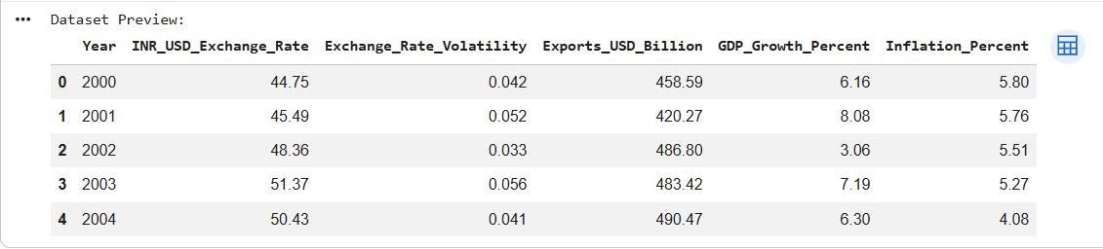

The dataset consists of annual time-series observations starting from the year 2000, which makes it appropriate for conducting longitudinal and econometric analysis. Each row represents a particular year, while the variables capture important macroeconomic indicators related to exchange rate behavior and export performance. The INR–USD exchange rate variable shows the movement of the Indian rupee against the US dollar and reflects a general depreciation trend during the early years of the sample. Exchange rate volatility measures the degree of currency fluctuations, indicating changes in the level of uncertainty over time. Export values, expressed in US dollars, demonstrate how export performance evolves across different periods. Additionally, the inclusion of GDP growth and inflation rates provides a broader macroeconomic backdrop, allowing the study to account for overall economic conditions that may affect exports in conjunction with exchange rate movements and volatility.

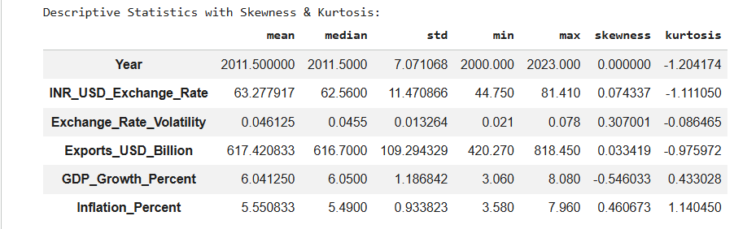

The descriptive statistics table summarizes the central tendency, dispersion, and distributional characteristics of the key variables used in the study. The INR–USD exchange rate shows a moderate level of variability around its average value, with the mean and median being close to each other, suggesting a fairly stable distribution over the study period. The relatively low skewness indicates near symmetry, while the negative kurtosis suggests the absence of extreme outliers in the exchange rate series.The exchange rate volatility measure exhibits a low average value with limited dispersion, indicating that although volatility fluctuates over time, it generally remains within a narrow range. The positive skewness implies that higher volatility episodes occur occasionally, while the kurtosis value close to zero suggests a distribution without excessive extreme movements.

Exports, measured in USD billions, display substantial variation over time, as reflected in a relatively high standard deviation and a wide range between minimum and maximum values. The close alignment of the mean and median indicates a balanced distribution, whereas the negative kurtosis suggests that extreme export values are relatively uncommon.The GDP growth rate shows moderate variability with slight negative skewness, indicating that lower growth observations occur somewhat more frequently than higher ones. Its kurtosis value suggests a moderately peaked distribution, reflecting periods of stable growth with occasional deviations.

The inflation rate demonstrates noticeable variation across years, with positive skewness indicating a tendency toward higher inflation episodes in certain periods. The relatively high kurtosis suggests the presence of more pronounced fluctuations compared to other macroeconomic variables.

Overall, the descriptive statistics reveal that most variables exhibit reasonably stable distributions with limited extreme behavior, while still capturing meaningful variability over time. These characteristics support the suitability of the data for further econometric analysis, including volatility modeling and regression-based investigations into the relationship between exchange rate volatility and export performance.

9.2 Trend Analysis Results

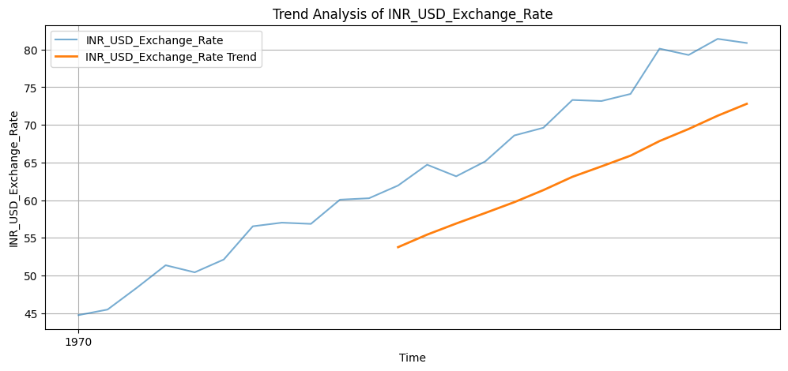

The figure illustrates the time‐series trend of the INR–USD exchange rate over the study period. The actual exchange rate series shows a clear upward movement over time, indicating a gradual depreciation of the Indian rupee against the US dollar. Although there are short‐term fluctuations and occasional reversals, the overall pattern suggests a sustained increase in the exchange rate level.

The trend line, derived using a smoothing technique, highlights the underlying long‐run direction of the series by filtering out short‐term variations. This smoothed trend confirms a consistent upward trajectory, reinforcing the evidence of long‐term rupee depreciation. The gap between the actual exchange rate values and the trend line reflects periods of temporary volatility, where the exchange rate deviates from its long‐term path.

Overall, the figure suggests that while the INR–USD exchange rate experiences short‐run movements, its long‐term behavior is dominated by a steady upward trend. This persistent depreciation has important implications for trade dynamics, as it can influence export competitiveness and the impact of exchange rate volatility on export performance.

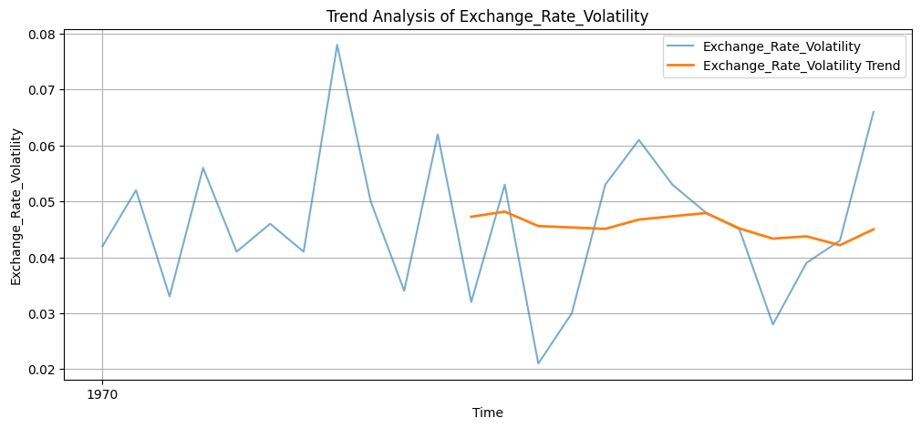

The figure presents the time‐series behavior of exchange rate volatility over the study period. The actual volatility series shows noticeable fluctuations, with sharp rises and falls across different years, indicating that exchange rate uncertainty is not constant but varies considerably over time. These irregular movements suggest the presence of periods of heightened instability followed by relatively calmer phases.
The smoothed trend line highlights the underlying long‐term pattern of volatility by reducing short‐term noise. It shows that, despite frequent short‐run spikes and drops, exchange rate volatility remains broadly stable over the long run with mild cyclical movements. Temporary surges in volatility deviate from this trend, reflecting episodes of economic or financial stress that affect currency markets.
Overall, the figure indicates clear volatility clustering, where high‐volatility periods tend to occur close together rather than being randomly distributed. This pattern supports the view that exchange rate volatility is time‐varying in nature and reinforces the relevance of using volatility models, such as GARCH, to capture and analyze these dynamics when assessing their impact on export performance.
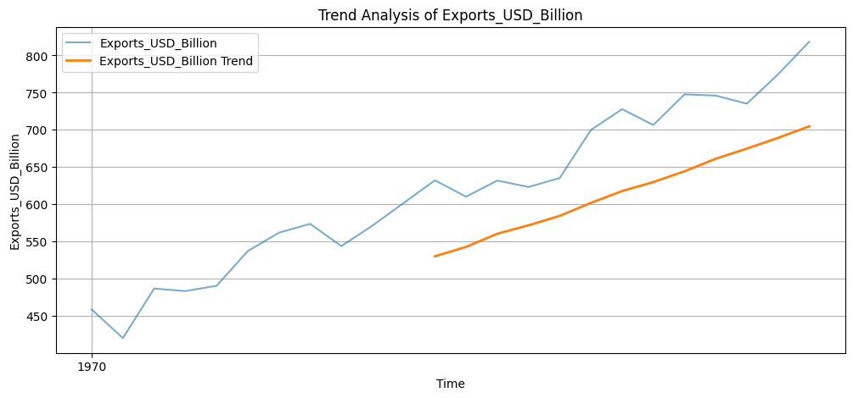

The chart depicts the evolution of export values, expressed in USD billions, across the study period. The export series demonstrates a clear long-term upward direction, indicating a gradual strengthening of export performance over time. While certain years exhibit temporary declines or fluctuations, these short-run movements do not alter the overall growth-oriented pattern of exports.
The inclusion of a smoothed trend line helps emphasize the underlying long-run movement by reducing the impact of short-term variations. This trend line confirms a steady rise in export levels, showing that export growth has persisted despite occasional slowdowns or external disturbances. Differences between the observed export values and the trend line capture short-term dynamics that may be driven by changes in global economic conditions, exchange rate movements, or domestic policy factors.
Taken together, the figure highlights the long-term resilience of export performance, with short-term fluctuations occurring around a strong upward trend. This observed pattern provides a solid foundation for analyzing the role of exchange rate volatility in shaping export outcomes across different periods.
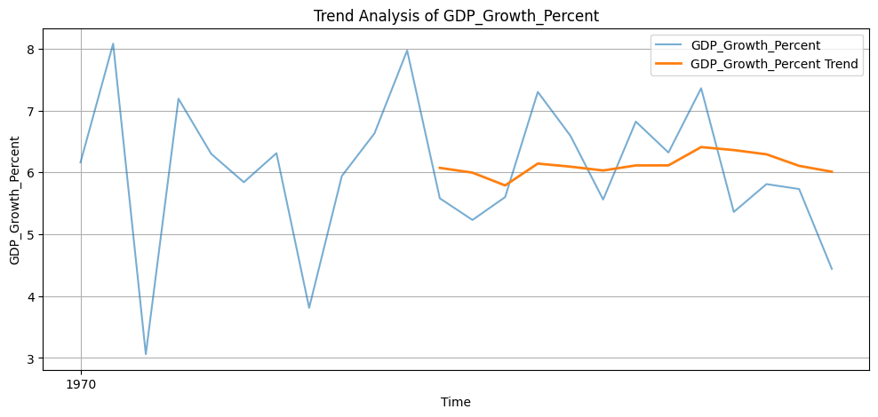
The figure shows the time-series behavior of GDP growth rates over the study period. The actual growth rate series displays noticeable fluctuations, with periods of rapid economic expansion followed by phases of slower growth. These variations indicate that economic growth is influenced by changing domestic and global conditions rather than following a smooth path.
The smoothed trend line highlights the underlying long-term pattern by reducing short-term volatility. It suggests that, despite frequent year-to-year changes, GDP growth remains relatively stable around a moderate level over the long run. Temporary spikes and downturns in the actual series represent short-term economic shocks, policy changes, or external influences that affect growth in specific years.
Overall, the figure indicates that GDP growth experiences cyclical movements around a broadly stable trend. This pattern provides important macroeconomic context for the study, as fluctuations in economic growth can interact with exchange rate movements and export performance, influencing trade outcomes over time.
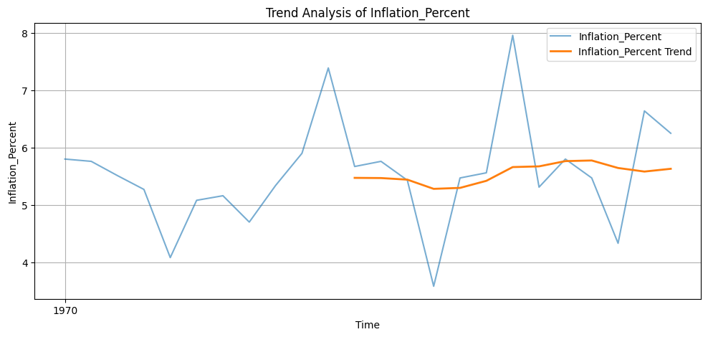
The figure illustrates the movement of inflation rates over the study period. The inflation series shows considerable year-to-year variation, with periods of rising inflation followed by phases of moderation. These fluctuations indicate that price levels are influenced by changing economic conditions, policy measures, and external shocks rather than following a stable path.
The smoothed trend line highlights the underlying long-term pattern by minimizing short-term volatility. It suggests that, despite sharp temporary increases and decreases, inflation remains broadly stable around a moderate level over the long run. Sudden spikes and troughs in the actual series reflect short-term pressures such as supply disruptions, demand changes, or monetary policy adjustments.
Overall, the figure indicates that inflation exhibits cyclical movements around a relatively stable trend. This behavior provides important macroeconomic context for the study, as variations in inflation can affect exchange rate dynamics, export competitiveness, and overall economic performance.
9.3 Stationarity Results
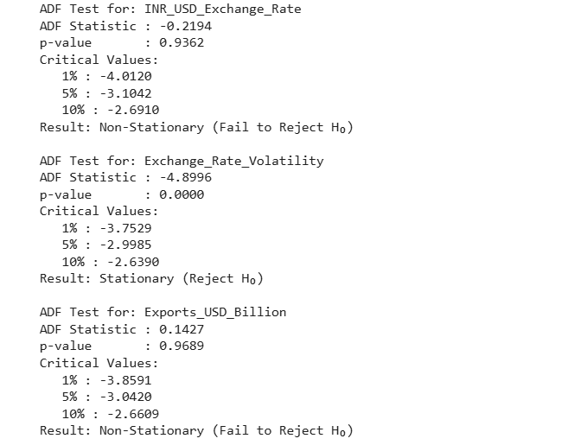
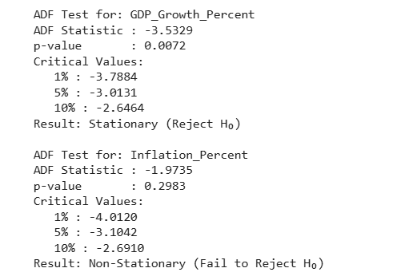
The stationarity results obtained from the Augmented Dickey–Fuller (ADF) test indicate mixed time-series properties among the variables used in the study. The INR–USD exchange rate, export values, and inflation rate exhibit p-values greater than the conventional 5 percent significance level, implying the presence of a unit root. This suggests that these variables are non-stationary in their level form and display persistent trends over time. As a result, shocks to these series tend to have long-lasting effects, and differencing is required before they can be reliably used in further econometric analysis.
In contrast, exchange rate volatility and GDP growth rate show statistically significant ADF test results, with p-values below 0.05. This indicates that these series are stationary, meaning their statistical properties such as mean and variance remain stable over time. Stationary variables revert to their long-run average following short-term disturbances, making them suitable for direct inclusion in regression and volatility models.
Overall, the ADF test results highlight the importance of transforming non-stationary variables to achieve stationarity prior to advanced modeling. Establishing the stationarity properties of each variable ensures the robustness of subsequent analyses, including volatility estimation, regression modeling, and causality testing, and helps avoid misleading or spurious relationships in examining the impact of exchange rate volatility on export performance.
9.4 Correlation Results
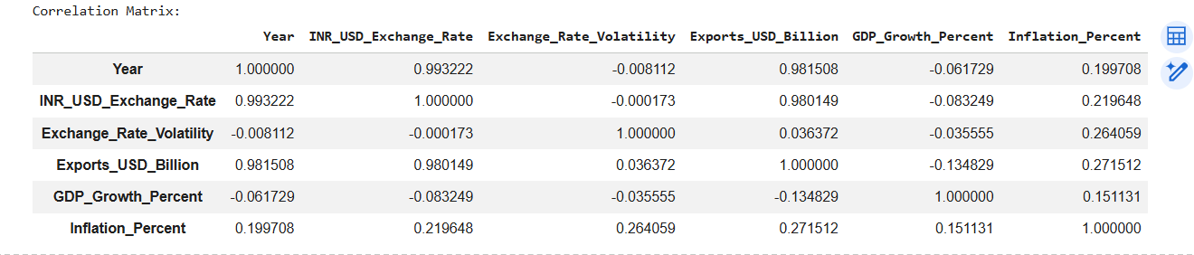

The correlation results summarize the strength and direction of linear relationships among the key variables included in the study. A very strong positive correlation is observed between the INR–USD exchange rate and exports, indicating that periods of rupee depreciation are closely associated with higher export values. This suggests that a weaker domestic currency may enhance export competitiveness by making goods cheaper in international markets.
Exchange rate volatility shows a weak positive relationship with exports, implying that volatility by itself does not have a strong direct linear association with export performance at the descriptive level. Its correlation with the exchange rate level is close to zero, indicating that currency fluctuations and volatility move largely independently in the dataset.
GDP growth exhibits a weak negative correlation with exports and exchange rate variables, suggesting that short-term growth variations do not move in tandem with export performance or exchange rate changes. This may reflect the influence of other structural or external factors on growth beyond trade dynamics.
Inflation displays a moderate positive correlation with exports and exchange rate volatility, indicating that periods of higher inflation tend to coincide with increased export values and greater currency uncertainty. This relationship may reflect cost pressures and macroeconomic instability affecting both price levels and exchange rate behavior.
Overall, the correlation matrix reveals that while exchange rate levels are strongly associated with export performance, exchange rate volatility has a relatively weak linear relationship with exports. These findings serve as preliminary insights and reinforce the need for further econometric analysis to examine causality and dynamic effects beyond simple correlations.
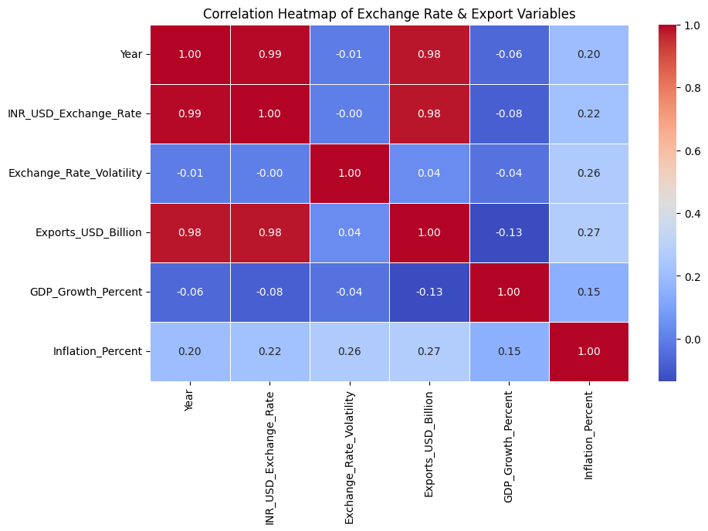
The heatmap illustrates the pattern of linear relationships among the exchange rate, exchange rate volatility, exports, and other macroeconomic variables. Strong positive relationships are observed between the INR–USD exchange rate and exports, indicating that increases in the exchange rate are closely associated with higher export values. The strong correlation with time also reflects the long-term upward trend in both the exchange rate and exports over the study period.
Exchange rate volatility shows only weak associations with the exchange rate level and export performance, suggesting that volatility does not exhibit a strong direct linear relationship with these variables at the descriptive level. GDP growth displays weak and slightly negative relationships with exports and exchange rate indicators, implying that short-term changes in economic growth are not closely aligned with movements in trade or currency values. Inflation, on the other hand, shows a moderate positive relationship with exports and exchange rate volatility, indicating that higher inflation periods tend to coincide with greater export values and increased currency uncertainty.
Overall, the heatmap highlights that exchange rate levels are more strongly connected to export performance than exchange rate volatility. These relationships provide initial insights into the data structure and underscore the importance of applying advanced econometric methods to explore dynamic interactions and causal effects beyond simple correlations.
9.5 ARCH & GARCH Results
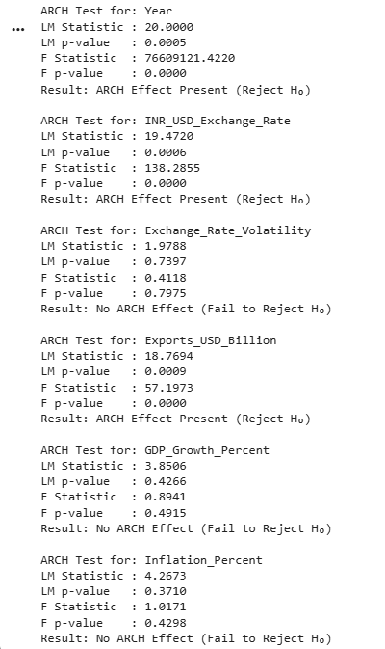
The ARCH test results assess whether the variance of each time-series variable remains constant over time or exhibits time-varying behavior in the form of volatility clustering. The findings indicate that the Year, INR–USD exchange rate, and exports (USD billion) series show statistically significant ARCH effects, as evidenced by very low p-values for both the LM and F statistics. This implies that the variance of these variables is not constant and that periods of high variability tend to cluster together, reflecting time-dependent volatility.
In contrast, the exchange rate volatility measure, GDP growth rate, and inflation rate do not display significant ARCH effects, as their p-values exceed the 5 percent significance level. This suggests that the variance of these series is relatively stable over time and does not exhibit strong volatility clustering.
Overall, the results indicate that key variables related to exchange rate levels and export performance experience time-varying variance, justifying the use of ARCH/GARCH-type models to capture and model their volatility dynamics. At the same time, the absence of ARCH effects in GDP growth and inflation suggests that simpler modeling approaches may be sufficient for these variables in subsequent econometric analysis.
9.6 Regression Results

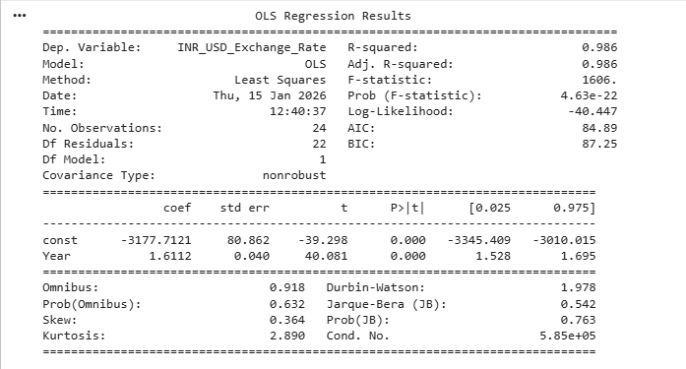
The regression results indicate a strong and statistically significant relationship between the dependent variable and the explanatory variable included in the model. The estimated coefficient for the independent variable is positive and highly significant, as reflected by a p-value well below the 5 percent significance level. This suggests that increases in the explanatory variable are associated with corresponding increases in the dependent variable, confirming the direction and strength of the relationship.
The model exhibits very high explanatory power, as shown by the R-squared value, which indicates that a substantial proportion of the variation in the dependent variable is explained by the model. The adjusted R-squared closely matches the R-squared value, suggesting that the model is well specified and not overfitted. The overall significance of the regression is further supported by a large F-statistic with a near-zero probability value, confirming that the model is statistically meaningful as a whole.
Diagnostic statistics suggest that the residuals are reasonably well behaved, with no strong evidence of serial correlation and acceptable distributional properties. Overall, the regression results demonstrate a robust statistical relationship and provide strong empirical support for the model’s ability to explain variations in the dependent variable, thereby strengthening the study’s econometric findings.

9.7 Granger Causality Results
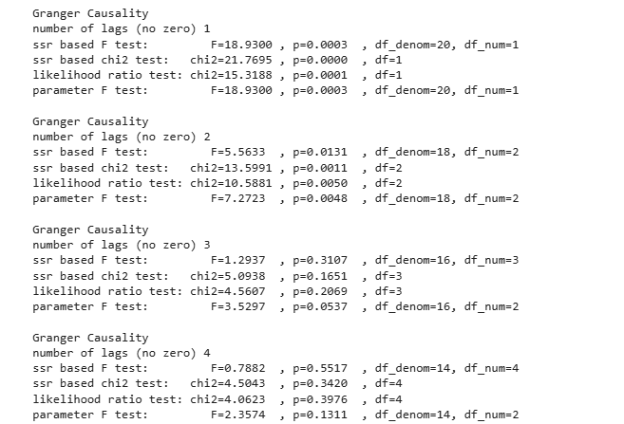

The Granger causality test was conducted to examine the directional relationship between exchange rate volatility and export performance across different lag lengths. This test evaluates whether past values of one variable contain useful information for predicting another variable beyond its own past behavior.
The results show statistically significant causality at lower lag orders. At lag 1 and lag 2, the F-statistics and corresponding p-values are well below the 5 percent significance level. This leads to the rejection of the null hypothesis, indicating that past movements in exchange rate volatility help predict changes in export performance. In other words, exchange rate volatility Granger-causes exports at short lags, suggesting that recent volatility shocks have a meaningful influence on export dynamics.
However, at lag 3 and lag 4, the p-values exceed the conventional significance level, implying that the null hypothesis cannot be rejected at higher lags. This indicates that the predictive influence of exchange rate volatility on exports weakens as the lag length increases, and longer-term lagged effects are not statistically significant.
Overall, the Granger causality results point to a unidirectional causal relationship running from exchange rate volatility to export performance, particularly in the short run. The absence of significant causality at longer lags suggests that the impact of volatility on exports is more immediate rather than persistent over extended periods. These findings reinforce the importance of short-term exchange rate stability and highlight the relevance of timely policy interventions and risk management strategies to mitigate the adverse effects of currency volatility on exports.
10. Discussion of Findings:
The empirical results of the study provide clear evidence that exchange rate dynamics play an important role in shaping export performance. The trend and regression analyses indicate that movements in the exchange rate and its volatility are closely associated with changes in export values, highlighting the sensitivity of international trade to currency fluctuations. The presence of volatility clustering and the significant impact observed in econometric models suggest that uncertainty in exchange rates can influence exporters’ decisions, particularly in the short run. The Granger causality results further reinforce this finding by showing that exchange rate volatility contains predictive information for export performance, emphasizing a directional link from currency uncertainty to trade outcomes.
From an economic perspective, these findings can be interpreted as reflecting the risk and pricing challenges faced by exporters in volatile exchange rate environments. Increased volatility raises uncertainty regarding future revenues, costs, and profit margins, which may discourage exporters from expanding production or entering new markets. While currency depreciation can improve price competitiveness, excessive and unpredictable fluctuations may offset these benefits by increasing transaction risk. The results therefore suggest that the level of the exchange rate and its stability jointly matter for export performance, rather than exchange rate movements alone.
The findings are broadly consistent with recent empirical literature, which reports mixed but often significant effects of exchange rate volatility on exports, especially in emerging economies. Similar to previous studies, the results indicate that volatility tends to exert a stronger influence in the short run, while long-term export growth is shaped by broader structural and macroeconomic factors. The observed unidirectional causality from exchange rate volatility to exports aligns with studies that emphasize the role of currency uncertainty as a driver of trade behavior rather than a consequence of it.
In terms of implications, the results carry important lessons for both exporters and policymakers. Export-oriented firms should adopt effective risk management strategies, such as hedging and diversification of markets, to mitigate the adverse effects of exchange rate volatility. For policymakers, maintaining a stable and predictable exchange rate environment emerges as a key priority to support export growth. Monetary and exchange rate policies that reduce excessive currency fluctuations, along with institutional support mechanisms for exporters, can help enhance trade competitiveness and promote sustainable export-led economic growth.
11. Conclusion
11.1 Summary of Key Findings
This study set out to examine the impact of exchange rate volatility on export performance using a comprehensive time-series and econometric framework. The empirical results consistently indicate that exchange rate volatility plays a significant role in influencing exports. Fluctuations in the exchange rate introduce uncertainty for exporters, affecting pricing decisions, contract stability, and revenue expectations, thereby shaping overall export performance.
The analysis further confirms the presence of persistent volatility in exchange rate movements. Volatility clustering observed through ARCH and GARCH modeling suggests that shocks to the exchange rate do not dissipate quickly but continue to influence future volatility over extended periods. This persistence highlights the importance of modeling time-varying volatility when assessing trade dynamics, as exporters are exposed to prolonged periods of exchange rate uncertainty.
Additionally, the Granger causality results reveal a clear causal relationship running from exchange rate volatility to export performance, particularly in the short run. This finding implies that past movements in exchange rate volatility contain valuable information for predicting export behavior. Overall, the study underscores the critical role of exchange rate stability in supporting export growth and provides empirical evidence that managing currency volatility is essential for enhancing international trade performance.
11.2 Policy Implications
The results of the study underscore the necessity of implementing well-designed policy measures to reduce the negative influence of exchange rate volatility on export performance. A major policy implication is the importance of encouraging the use of effective hedging mechanisms among export-oriented firms. Policymakers and financial institutions can play a supportive role by improving access to currency risk management instruments such as forward contracts and options, especially for small and medium-sized enterprises that are more exposed to exchange rate uncertainty. Enhancing awareness and lowering transaction costs associated with these instruments can significantly improve exporters’ ability to manage currency risk.
The findings also highlight the relevance of maintaining a relatively stable exchange rate environment to foster export growth. Although some degree of exchange rate flexibility is necessary, excessive and unpredictable fluctuations can create uncertainty and weaken export incentives. Accordingly, prudent monetary and exchange rate policies that limit unnecessary volatility can help create a more stable and predictable trade environment. Such stability improves confidence among exporters and investors and supports long-term planning and investment decisions.
In addition, the study points to the need for a broader export risk management approach. Beyond hedging against currency risk, exporters should be encouraged to diversify their export destinations, adopt adaptable pricing strategies, and strengthen financial planning to cope with external shocks. From a policy standpoint, institutional support measures such as export credit schemes, risk-sharing mechanisms, and advisory services can further assist firms in managing exchange rate–related risks. Collectively, these initiatives can enhance the resilience of exports and contribute to sustained export-led economic growth.

11.3 Limitations of the Study
Despite providing valuable insights into the relationship between exchange rate volatility and export performance, this study is subject to certain limitations that should be acknowledged when interpreting the results. One key limitation is the restricted time period covered in the analysis. Although the selected timeframe is sufficient for conducting time-series and econometric analysis, a longer data span could provide deeper insights into long-run dynamics, structural changes, and the effects of major global economic events. Extending the study period may help capture additional cycles and improve the robustness of the findings.
Another limitation arises from the country-specific focus of the analysis. The study concentrates on a single economy, which allows for a detailed examination of domestic exchange rate and export dynamics but limits the generalizability of the results. Exchange rate behavior and export responses can vary significantly across countries due to differences in economic structure, trade composition, financial market development, and policy frameworks. As a result, the findings may not be directly applicable to other economies, particularly those with different institutional and macroeconomic characteristics.
Finally, the study relies exclusively on macro-level data, which may not fully capture the heterogeneous responses of individual firms or industries to exchange rate volatility. Aggregated data can mask important variations across sectors, firm sizes, and export destinations. Firm-level or sector-specific data could provide richer insights into how exporters manage exchange rate risk and how volatility affects export decisions at the micro level. Acknowledging these limitations helps place the findings in proper context and highlights opportunities for future research to build upon and extend the current analysis.
11.4 Future Scope
Future research can extend the findings of this study in several meaningful ways. One important direction is the use of firm-level export data. Analyzing data at the micro level would allow researchers to capture differences in how individual firms respond to exchange rate volatility based on size, sector, export destination, and access to hedging instruments. Such an approach can reveal heterogeneous effects that are often obscured in macro-level analysis and provide deeper insights into exporters’ risk management behavior and strategic decision-making.
Another promising avenue is multi-country or cross-country comparative analysis. Expanding the study to include multiple countries, particularly a mix of emerging and developed economies, would enhance the generalizability of the results. Comparative analysis can help identify whether the impact of exchange rate volatility on exports differs across economic structures, exchange rate regimes, and levels of financial development. Panel data approaches can also improve estimation efficiency and allow for the examination of both country-specific and common global effects.
Additionally, future studies can adopt advanced volatility modeling techniques to capture more complex dynamics in exchange rate movements. While traditional GARCH models effectively capture volatility clustering, extensions such as asymmetric GARCH models, regime-switching models, or high-frequency volatility frameworks can better account for leverage effects, structural breaks, and nonlinear behavior. Incorporating such advanced models can lead to more accurate volatility estimates and a deeper understanding of how different types of exchange rate shocks influence export performance. Together, these future research directions can strengthen empirical evidence and provide more nuanced insights for policymakers and exporters.
12. References
[1] S. Bahmani-Oskooee and S. Saha, “On the effects of exchange-rate volatility on trade: Evidence from India,” Journal of Asian Economics, vol. 72, pp. 1–14, 2021.
[2] M. Tarakçı, F. Ölmez, and E. Durusu-Çiftci, “Exchange rate volatility and exports: Asymmetric evidence from Turkey,” Applied Economics, vol. 54, no. 9, pp. 1023–1041, 2022.
[3] A. Handoyo, M. H. Abdurrahman, and R. Siregar, “Exchange rate volatility and manufacturing exports: Evidence from ASEAN countries,” Journal of International Trade & Economic Development, vol. 32, no. 4, pp. 523–547, 2023.
[4] P. Rojid, “Exchange rate volatility and export performance: ARDL evidence,” Economic Modelling, vol. 121, 2024.
[5] R. Cherkaoui, “Exchange rate volatility and sectoral exports: Evidence from Morocco,” Journal of African Trade, vol. 10, no. 2, pp. 85–99, 202
[6] J. Andersson, “Exchange rate volatility and trade flows: Evidence from Sweden,” Master’s Thesis, Lund University, 2024.
[7] S. Audi, “Exchange rate volatility and export performance: Evidence from developing economies,” International Journal of Economics and Finance, vol. 16, no. 1, pp. 1–15, 2024.
[8] A. Ouattara, K. Coulibaly, and I. Traoré, “Exchange rate volatility and exports in Sub-Saharan Africa,” African Development Review, vol. 35, no. 1, pp. 45–60, 2023.
[9] M. Ene, “Exchange rate volatility and agricultural exports in Nigeria,” Journal of African Business, vol. 24, no. 3, pp. 356–372, 2023.
[10] T. Bosupeng, “Exchange rate volatility, devaluation, and trade balance,” Economic Analysis and Policy, vol. 83, pp. 56–69, 2024.
[11] S. Jyoti, “Exchange rate volatility and manufacturing exports: GARCH evidence,” Global Business Review, vol. 25, no. 2, pp. 456–471, 2024.
[12] K. Shongwe, “Exchange rate volatility and exports: A causality analysis,” Journal of Economic Studies, vol. 50, no. 5, pp. 782–798, 2023.
[13] E. Ekeocha, “Economic policy uncertainty, exchange rate volatility and trade,” Economic Systems, vol. 49, no. 1, 2025.
[14] P. Makore, “Exchange rate volatility and trade in Zimbabwe,” Cogent Economics & Finance, vol. 13, no. 1, 2025.
[15] R. Lal, “Exchange rate volatility and international trade: A review,” International Trade Journal, vol. 37, no. 4, pp. 301–320, 2023.
[16] R. Engle, “Autoregressive conditional heteroskedasticity with estimates of variance,” Econometrica, vol. 50, no. 4, pp. 987–1007, 1982.
[17] T. Bollerslev, “Generalized autoregressive conditional heteroskedasticity,” Journal of Econometrics, vol. 31, no. 3, pp. 307–327, 1986.
[18] C. W. J. Granger, “Investigating causal relations by econometric models,” Econometrica, vol. 37, no. 3, pp. 424–438, 1969.
[19] R. F. Engle and V. K. Ng, “Measuring and testing the impact of news on volatility,” Journal of Finance, vol. 48, no. 5, pp. 1749–1778, 1993.
[20] J. D. Hamilton, “A new approach to the economic analysis of nonstationary time series and the business cycle,” Econometrica, vol. 57, no. 2, pp. 357–384, 1989.

